Salesforce Administrator Self-Learning & Super Badges

SALESFORCE ADMINISTRATOR - SELF LEARNING

Sub heading:- Salesforce Chatter

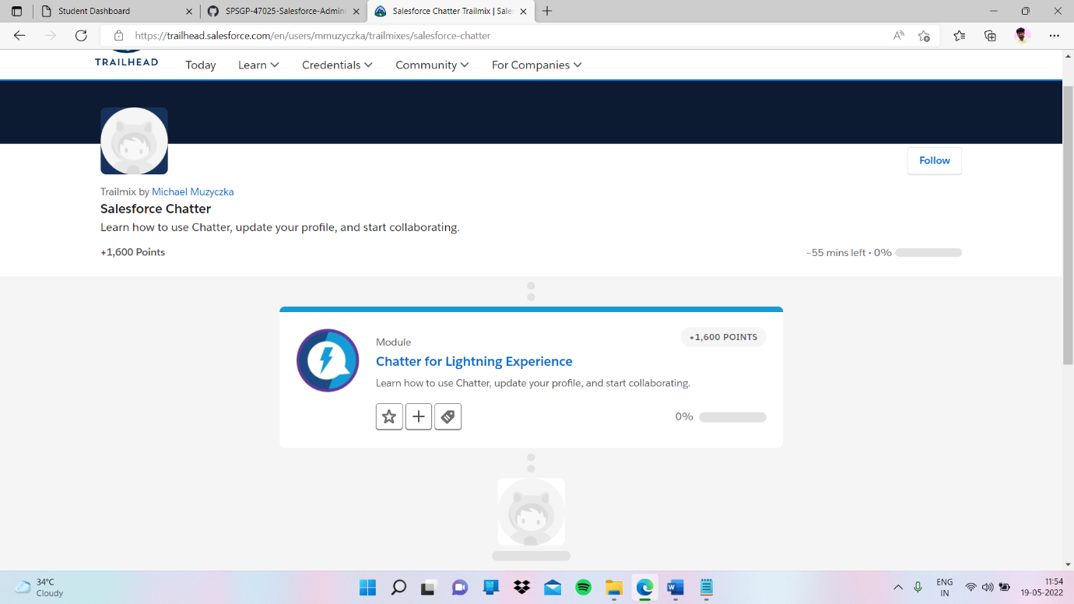

Sub heading:- Chatter for Lightning Experience

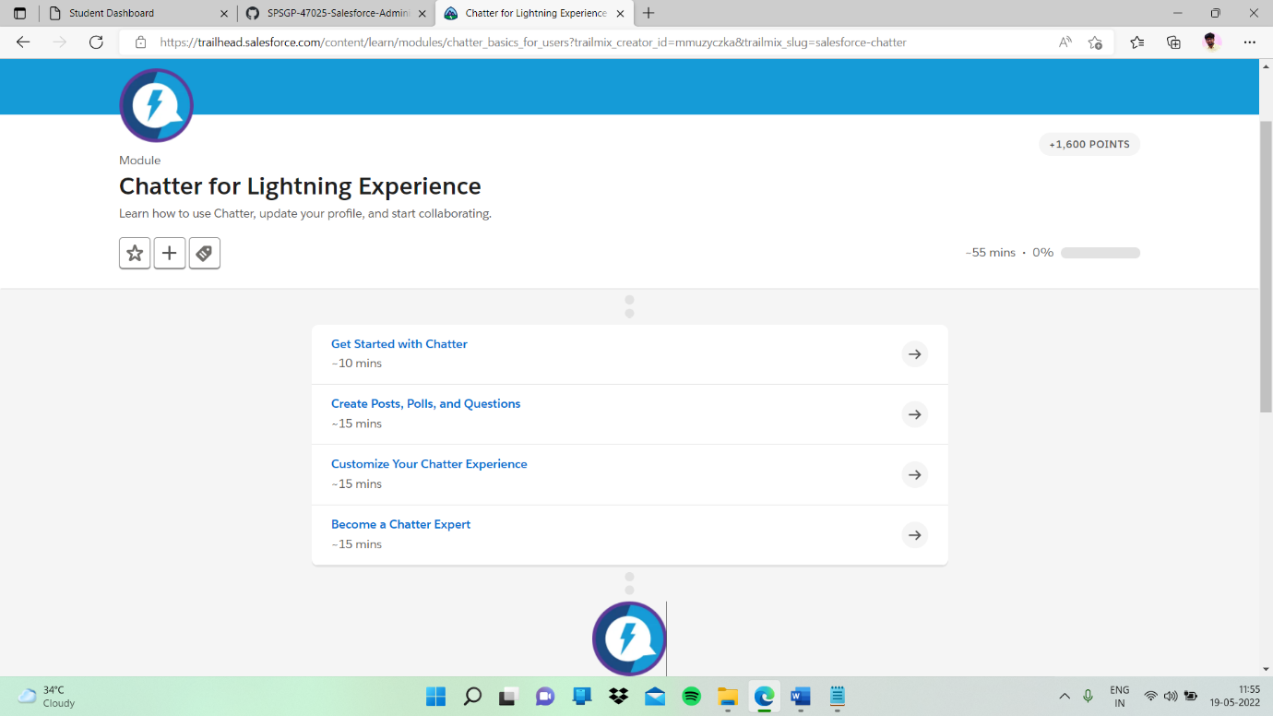

Sub topic:- Get Started with Chatter

My task:-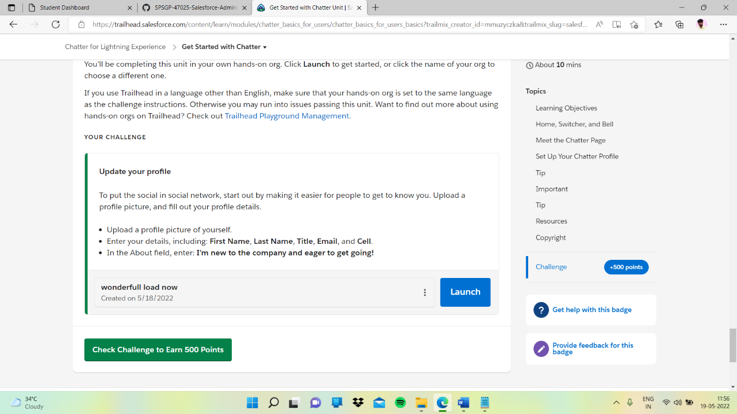

I clicked launch button

In this I updated my profile

